 |  |  | What is covered in the document
State | Department | Year/Code (with weblink) | Compost | Render | Landfill | Bury | Burn | Other
Alabama  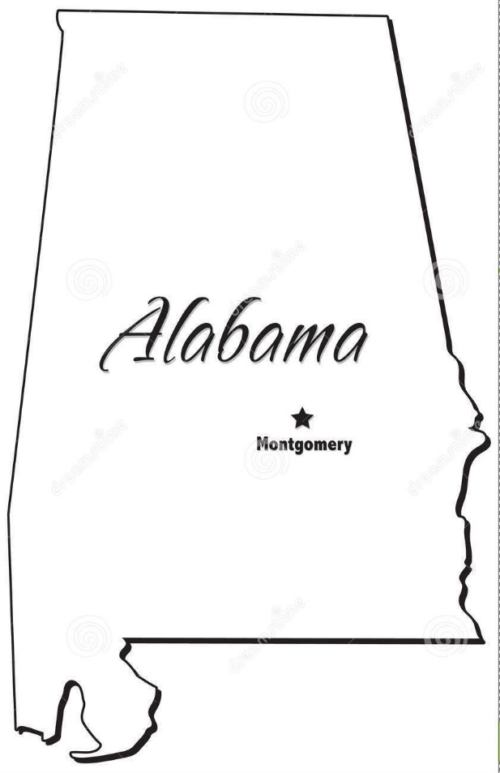 | Alabama State Board of Agriculture | 2005/Alabama Job Sheet No. AL316 NRCS Animal Mortality Facility
 |  | 2009/Alabama Emergency Disposal of Dead Animals
 | Alabama General Legislation | 2006/ALA CODE 3-1-28
 |  | 2006/ALA CODE 2-16-41
 | Alabama Department of Environmental Management | 2000/ ADEM Admin Code Chapter 335-6-7- .26 (2)(i)
Alaska  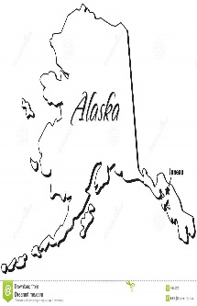 | Alaska Department of Environmental Conservation | 2016/FAQ How do I dispose of Animal Remains?
 |  | 2002/18 ACC 60.010 (d)
 | Alaska Division of Agriculture | 2006/9 CFR 53.4
 | Alaska General Assembly | 2007/AS 46.03.810
Arizona  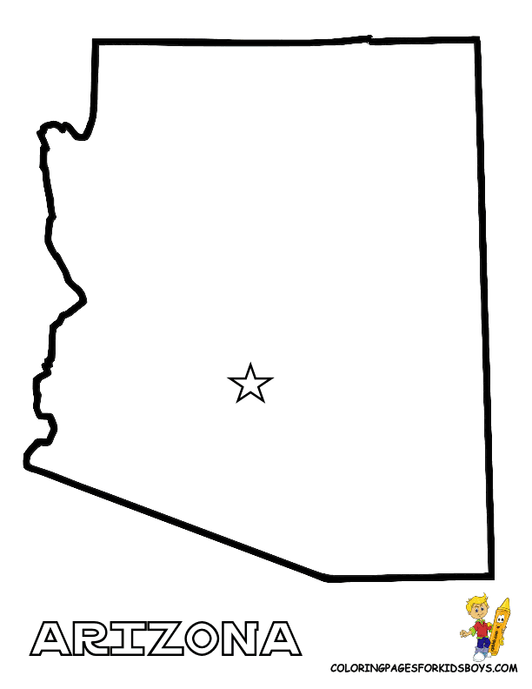 | Arizona Department of Environmental Quality | 2016/ Environmental Quality, Solid Waste Management, Refuse and Other Objectionable Wastes, Disposal: R18-13-311 - General and R18-13-312 Methods of Disposal
 | Arizona Department of Agriculture | 2009/ R3-2-206. Agriculture, Meat and Poultry Inspection, Purchase, Sale, Collection, Transportation, Disposition, and Use of Meat or Meat Food Products; Dead Animals; Animal bone, Animal Fat, Animal Offal
Arkansas  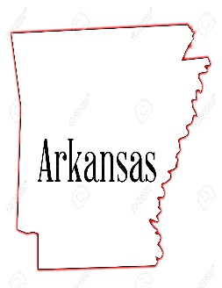 | Arkansas Livestock and Poultry Commission | 2004/Regulation for the Disposal of Large Animal Carcasses |  |  | Not Allowed
 |  | 1992/Carcass Disposal of Poultry
 |  |  | What is covered in the document
State | Department | Year/Code (with weblink) | Compost | Render | Landfill | Bury | Burn | Other
California  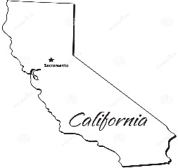 | California Department of Food and Agriculture | 1967/CDFA Code 9141 – 9143
 |  | 2010/California Section 17855.2 Prohibitions | Prohibited
 | California Environmental Protection Agency | 2006/Emergency Animal Disposal: Cal/EPA Emergency Response and Disaster Preparedness
Colorado | Colorado Department of Public Health and Environment | 2013/Emergency Livestock Disposal Policy
 | Colorado State University, Integrated Livestock Management Board | 2006/Composting
Connecticut | Connecticut Department of Agriculture | 1971/Sec. 22-324a: Sanitary disposal facilities for dead poultry
 | Connecticut General Assembly | 2004/Title 22, Chapter 433, Section 22-316: Disposal of diseased cattle and goats
Delaware  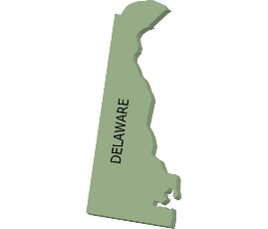 | Delaware Department of Agriculture | 2005/Nutrient Best Management Practice Booklet
 |  |  | What is covered in the document
State | Department | Year/Code (with weblink) | Compost | Render | Landfill | Bury | Burn | Other
Florida  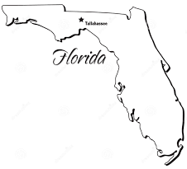 | University of Florida IFAS Extension | 2013/The Florida Handbook of Solid and Hazardous Waste Regulation: Biological and Animal Waste Disposal
 | Florida Department of Agriculture and Consumer Services (FDOACS) | 2008/ Title 46, 823.041: Disposal of bodies of dead animals; penalty
Georgia  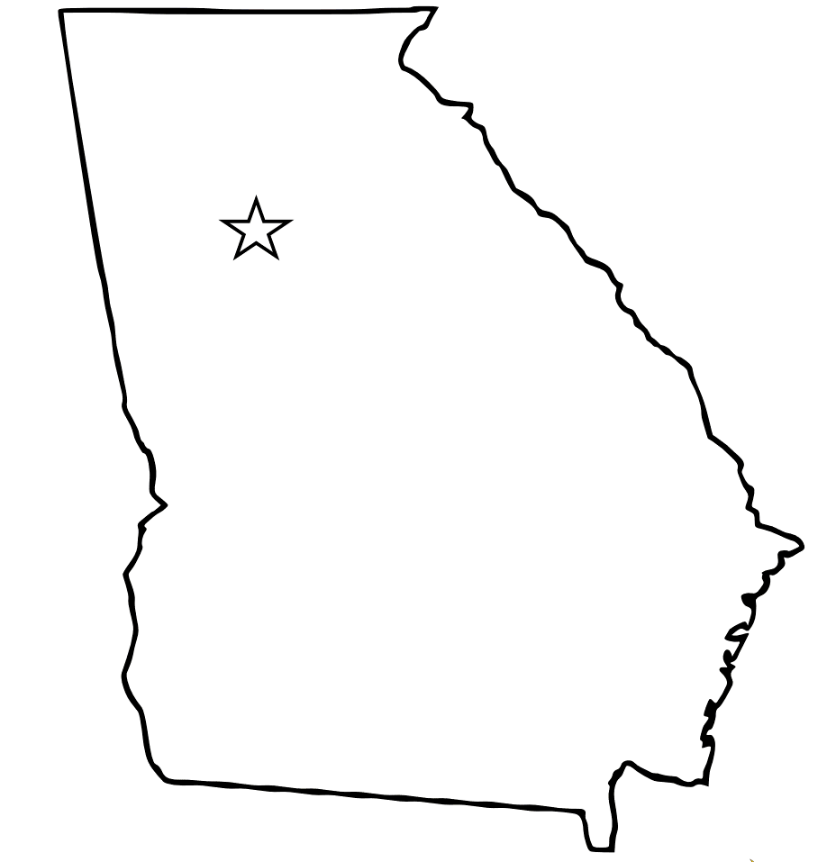 | Georgia College of Agricultural and Environmental Sciences (Cooperative Extension Service) | 2004/Mortality Management Options for Georgia Poultry Growers Publication B1244
 |  | 2005/ Poultry Mortality Composting Management Guide Publication B1266
 | Georgia Department of Agriculture Animal Industry Division | 2003/ Rules of Georgia Department of Agriculture Animal Industry Division Chapter 40-13-5: Dead Animal Disposal
 | Georgia General Assembly | 2010/ O.C.G.A. Title 4 - Animals, Chapter 5 - Disposal of Diseased, Disabled, or Dead Animals
Hawaii | Hawaii Cooperative Extension Service, College of Tropical Agriculture and Human Resources, University of Hawaii at Manoa | 2000/Minimizing Pollution Risk from Livestock Operations
 | Hawaii Department of Health, Solid Waste Management Branch | 1994/Hawaii Administrative Rules, Title 11, Department of Health, Chapter 58.1, Solid Waste Management Control, Subchapter 6, Section 11-58.1-61
Idaho  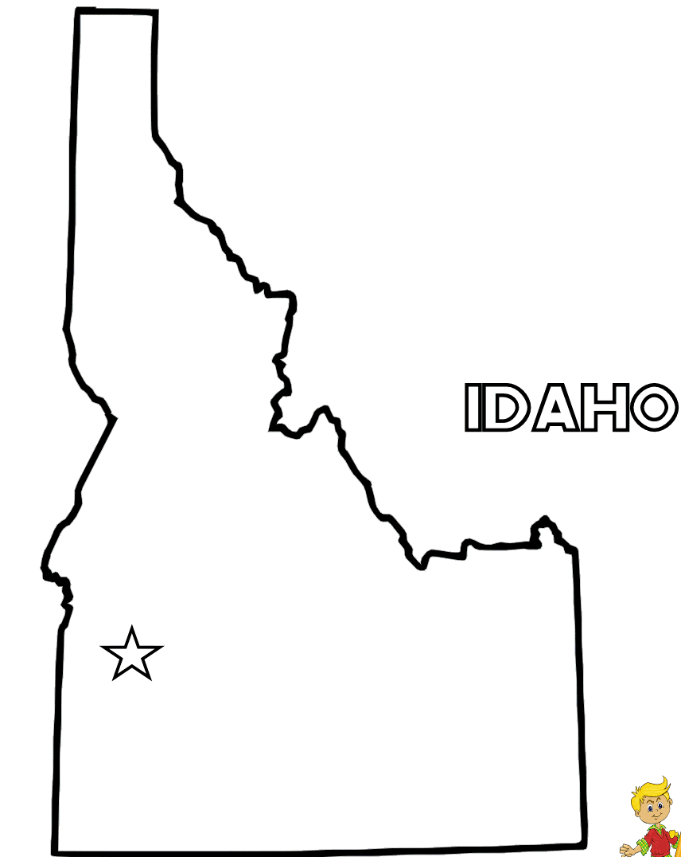 | Idaho Department of Agriculture | 2010/IDAPA 02, Title 04, Chapter 17, 02.04.17: Rules Governing Dead Animal Movement and Disposal
 |  |  | What is covered in the document
State | Department | Year/Code (with weblink) | Compost | Render | Landfill | Bury | Burn | Other
Illinois | Illinois Department of Agriculture | 2010/225 ILCS 610/Illinois Dead Animal Disposal Act
 |  | 2004/ Title 8, Chapter 1, Subchapter b, Part 90: Illinois Dead Animal Disposal Act
Indiana | Indiana State Board of Animal Health (BOAH) | 2008/Dead Animal Disposal
 |  | 2008/ 345 IAC 7-7-3.5 Composting
 | Indiana General Assembly | 2010/ Indiana Code IC 15-17-10: Disposal of Dead Animals
Iowa | Iowa Department of Natural Resources | 2008/Dead Animal FAQ
 |  | 1999/Composting dead livestock: A new solution to an old problem
 | Iowa Legislature | 2007/Iowa Administrative Code: IAC 567, Title I, Chapter 105: Organic Materials Composting Facilities
 | Iowa State University Extension | 2008/DisSolving Swine Mortality Problems
 |  | 2008/Emergency Composting of Cattle Mortalities
Kansas  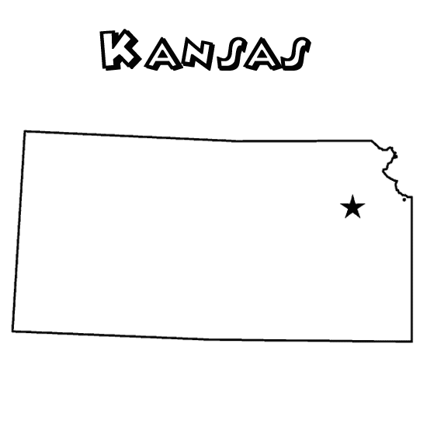 | Kansas Department of Health and Environment | 2004/Disposal Options for Small Quantities of Dead Animals: Technical Guidance Document SW 94-01
 |  | 2003/Disposal Options for Large Quantities of Dead Animals: Technical Guidance Document SW 01-01
 |  | 1999/ KAR 28-29-25d (page 57) Livestock Composting
 |  | 2001/ Bureau of Waste Management Policy 2010-P3 related to Permitting Requirements for Dead Animal Burial Sites
 | Kansas State Legislature | 1997/ KSA 47-1219: Animal removal: Unlawful disposal; penalty
 |  | 2001/ KSA 65-3407c: Exemptions from permit requirement
 |  |  | What is covered in the document
State | Department | Year/Code (with weblink) | Compost | Render | Landfill | Bury | Burn | Other
Kentucky  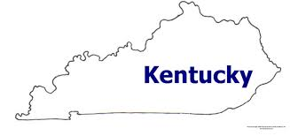 | Kentucky Cooperative Extension Service | 2013/On-Farm Composting of Animal Mortalities - Bulletin ID-166
 |  | 2013/On-Farm Disposal of Animal Mortalities- Bulletin ID-167
 | Kentucky State Board of Agriculture | 2011/KRS 257.160: Disposition of carcasses
 |  | 2011/Kentucky 302 KAR 20:052E: Animal carcass composting
Louisiana | Louisiana Department of Agriculture and Forestry | 2008/RS 3:2131: Cremation or burial of animal carcasses
 | Louisiana State University Ag Center | 2000/ Poultry Best Management Practices
 |  | 2000/ Swine Production Best Management Practices (BMPs)
Maine | University of Maine Cooperative Extension | 2015/Safe Disposal of Backyard Poultry Mortalities – Bulletin #12
 | Maine Department of Agriculture, Food and Rural Resources | 2012/Chapter 211: Rules for the Disposal of Animal Carcasses
Maryland | Maryland Cooperative Extension | Composting Animal Mortalities on the Farm Fact Sheet 717
 |  | 1991/Composting Dead Birds – Fact Sheet 537
 | Maryland Department of Agriculture | 2013/Annotated Code of Maryland, Agriculture Article 3-108
 |  |  | What is covered in the document
State | Department | Year/Code (with weblink) | Compost | Render | Landfill | Bury | Burn | Other
Massachusetts | Massachusetts Department of Agricultural Resources | 2011/MDAR 330 CMR 25.00: MDAR's Agricultural Composting Program
 |  | Legal Statutes MGL Chapter 129: Livestock Disease Control, Section 14
 | University of Massachusetts Extension | 2009/Livestock and Poultry BMPs: A Handbook for Massachusetts Livestock & Poultry Best Management Practices
 |  | UMass Extension Publication CDLE Pub. 08-14: Disposal of Dead Livestock & Equine
 | Massachusetts Department of Environmental Protection | 2007/ Avian Flu and Other Carcass Management Planning
Michigan  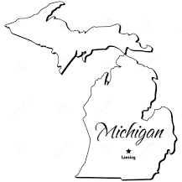 | Michigan Department of Agriculture | Proper Disposal of Animal Carcasses in Michigan
 |  | 1998/ Bodies of Dead Animals Act, Public Act 239 of 1982
 | Michigan State University | 2015/ Resources About Managing Animal Tissue to Recycle Nutrients
Minnesota | Minnesota Board of Animal Health | 1999/Minnesota Statutes 2008: 35.82 Rendering Plant Permits; Disposition of Carcasses (Subd 2)
 |  | 2004/Minnesota Administrative Rules, Chapter 1719, Animal Carcasses
 |  | 2017/Minnesota Carcass Disposal
 |  | 2009/Composting Animal Mortalities on the Farm
Mississippi | Mississippi Board of Animal Health | 2008/Rules of the Mississippi Board of Animal Health Chapter 07: Disposition of Dead Animals
 |  | 2008/Rules of the Mississippi Board of Animal Health Chapter 13: Poultry sections 105 and 106
 |  |  | What is covered in the document
State | Department | Year/Code (with weblink) | Compost | Render | Landfill | Bury | Burn | Other
Missouri | Missouri Department of Agriculture | 2011/Missouri Revised Statutes: Chapter 29: Disposal of Dead Animals, Section 269.020
 |  | 2008/Catastrophic Mortality and Associated Material Disposal: Standard Operating Guideline No. 002
 | University of Missouri Extension | 1994/ Dead Animal Disposal Laws in Missouri - Bulletin WQ216
 |  | 1996/ Composting Dead Swine - Bulletin WQ351
 | Missouri Department of Natural Resources | 2017/ Animal Production Mortalities Emergency Procedures
Montana  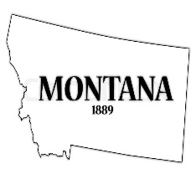 | Montana Department of Livestock | 2007/ Rule 32.6.1102: The Handling of Dead Animals or Fowl
 |  | 2006/ Rule 32.6.711: Disposal of Offal, Paunch Contents, and Other Viscera
 | Montana Department of Environmental Quality | 2015/ Montana Code Annotated 75-10-213
 |  | 2015/ Montana Code Annotated 75-10-214
Nebraska  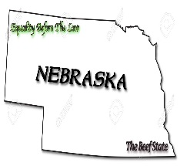 | Nebraska Department of Agriculture | 2014/ General Powers and Miscellaneous Animal Health Statutes: Chapter 54, Sections 743 - 745.
 |  | 2010/ Nebraska Administrative Code, Title 23, Chapter 17:Livestock Composting Regulations
 | Nebraska Cooperative Extension, Institute of Agriculture and Natural Resources, University of Nebraska-Lincoln | 2010/ Publication EC727: Disposal Methods of Livestock Mortality
 |  |  | What is covered in the document
State | Department | Year/Code (with weblink) | Compost | Render | Landfill | Bury | Burn | Other
Nevada | Nevada Department of Agriculture | 2003/ NRS 571.200 Disposal of carcass of diseased animal
 | Nevada Division of Environmental Protection | 2007/ NDEP Fact Sheet - Agriculture Waste Exemptions
New Hampshire | New Hampshire Department of Environmental Services | 2009/ Fact Sheet WMD-SW-20, 2009: Disposal of Dead Animals
New Jersey  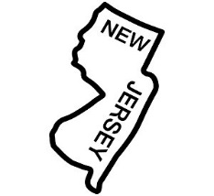 | New Jersey Department of Agriculture, Division of Agriculture and Natural Resources | 2009/ NJAC Title 2: Agriculture, Chapter 91: Animal Waste Management (NJAC 2:91)
New Mexico | New Mexico Cooperative Extension Service, College of Agriculture and Home Economics at New Mexico State University | 2002/ Guide D-108: Whole Animal Composting of Dairy Cattle
 |  | 2010/ Dairy Technical and Regulatory Guidance Manual for New Mexico Circular 639
 | New Mexico Environment Department | 2007/ New Mexico 20.9.5: Solid Waste, Environmental Protection, Solid Waste Facility and Commercial Haulers Operating Requirements
 |  | 2007/ New Mexico 20.9.3: Environmental Protection, Solid Waste, Solid Waste Facility Permits and Registrations
 |  |  | What is covered in the document
State | Department | Year/Code (with weblink) | Compost | Render | Landfill | Bury | Burn | Other
New York | New York State College of Agriculture and Life Sciences, Cornell Waste Management Institute | 2002/ Natural Rendering: Composting Livestock Mortality and Butcher Waste
 |  | 2008/Avian Influenza and Poultry Composting
 |  | 2007/ Composting Road Kill
 |  | 2012/ Horse Mortality: Carcass Disposal
 | New York State Department of Agriculture and Markets, Soil and Water Conservation District and Agricultural Environmental Management | 2005/ Waste Disposal
 |  | 2010/ NY Agriculture and Markets Article 26: Section 377 Disposal of dead animals
 | New York State Department of Environmental Conservation, Solid Waste Management | 2017/ Solid Waste Management Regulations, 6 NYCRR Part 360
North Carolina | North Carolina State University Livestock and Poultry Environmental Stewardship Curriculum | 2005/ Managing Animal Deaths: Your Options
 |  | 2007/ Composting Poultry Mortality
 | North Carolina Department of Agriculture and Consumer Services: Veterinary Division | 2009/ NCGS 106-403: Disposition of dead domesticated animals
 |  | 1984/ NCAC 52C .0102: Disposal of Dead Animals
 |  |  | What is covered in the document
State | Department | Year/Code (with weblink) | Compost | Render | Landfill | Bury | Burn | Other
North Dakota  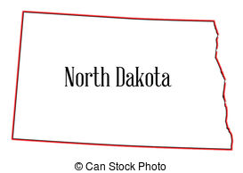 | North Dakota State University | 2009/Animal Carcass Disposal Options
 | North Dakota Department of Health, Division of Waste Management | 2007/ Guideline 32 - Composting Poultry and Other Dead Animals
 | North Dakota Department of Agriculture, Board of Animal Health | 2007/ Title 36: Livestock, Section 14: Contagious and Infectious Diseases General: 36-14-19: Disposition of carcass of animal dying from contagious or infectious disease
 |  | 2017/ Standard Poultry Biosecurity Plan
Ohio | Ohio Department of Agriculture | 1994/Ohio Revised Code: Title IX Agriculture - Animals - Fences: Chapter 941: Animal Diseases - 941.14 Disposal of dead or destroyed animals
 |  | 2006/Mortality Management Plan
 | Ohio Division of Soil and Water Conservation | 2001/ Ohio Revised Code: Title XV Conservation of Natural Resources: Chapter 1511: Division of Soil and Water Conservation, 1511.022 Composting of dead animals
Oklahoma  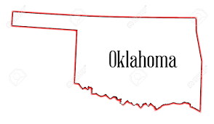 | Oklahoma Department of Agriculture, Food and Forestry (ODAFF) | 2014/ Agricultural Environmental Management Services (AEMS) - Carcass Disposal Options
 |  | 2010/ Carcass Disposal: Includes Title 21. Oklahoma Criminal Statutes, Title 2. Oklahoma Statutes, Carcass disposal options (above), Municipal Solid Waste Landfills
 | Oklahoma State University Cooperative Extension Service | 2010/ Proper Disposal of Routine and Catastrophic Livestock and Poultry Mortality
 |  | 2010/ On-Farm Mortality Composting of Livestock Carcasses
 |  |  | What is covered in the document
State | Department | Year/Code (with weblink) | Compost | Render | Landfill | Bury | Burn | Other
Oregon | Oregon Department of Agriculture | 2013/ Safe and Legal Disposal of Animal Carcasses
 |  | 2011/ Oregon Revised Statutes, Chapter 601-Dead Animals
Pennsylvania | Pennsylvania State Extension | 2017/ Penn State Extension Mortality Disposal Website
 |  | 2017/ Livestock and Poultry Mortality Disposal in Pennsylvania
 | Pennsylvania Department of Agriculture | 2007/ Title 3, Chapter 23, Subchapter E - Disposal of Dead Domestic Animals and Animal Waste
Rhode Island | Rhode Island Department of Environmental Management, Division of Agriculture | Emergency Response Plan for Disposal of Poultry and Litter from an AI outbreak
South Carolina | South Carolina Department of Health and Environmental Control | 2002/ SC DHEC regulation 61-43: Standards for Permitting of Agricultural Animal Facilities
 | South Carolina Extension, Clemson University | Certification Program for Animal Manure Management: Dead Animal Disposal
South Dakota  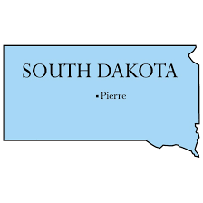 | South Dakota Animal Industry Board | 2003/ Disposal of Dead Animals: Guidelines for On-Farm Disposal
 |  | 2005/ Disposal of Livestock Mortality for SD
 | South Dakota Legislature | 1990/ SD Codified Law 40-5-15
 |  |  | What is covered in the document
State | Department | Year/Code (with weblink) | Compost | Render | Landfill | Bury | Burn | Other
Tennessee | Tennessee Agricultural Extension Service, University of Tennessee – Knoxville | 2010/ W255: Disposing of Large Animal Mortalities in Tennessee
 | Tennessee Department of Agriculture | 2009/ Policy Concerning the Disposal of Dead Farm Animals and The Disposal Offal from Custom Slaughter Facilities
Texas  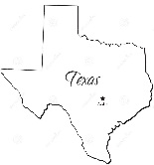 | Texas Commission on Environmental Quality | 2005/ RG-419 Disposal of Domestic or Exotic Livestock Carcasses
 |  | 2009/ Handling and Disposal of Carcasses from Poultry Operations
 | Texas Department of Agriculture | 2005/ NRCS Standard: Animal Mortality Facility #316
Utah | Utah State University Extension | 1999/ AG-507, Cow Mortality Disposal
 | Utah Department of Agriculture and Food, Division of Animal Industry | 1979/ Utah Code and Constitution, Title 04 - Chapter 26 - Dead Animals
 |  | 1973/ Utah Code and Constitution, Title 04 - Chapter 31 - Livestock Inspection and Quarantine - Section 12
 |  |  | What is covered in the document
State | Department | Year/Code (with weblink) | Compost | Render | Landfill | Bury | Burn | Other
Vermont  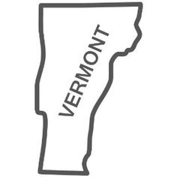 | Vermont Extension, University of Vermont | 2010/ Healthy Farms - Healthy Agriculture: Disposal of Dead Animals
 | Vermont Department of Environmental Conservation Waste Management Division | 2001/ Solid Waste Management Procedures: Procedure Addressing Disposal of Dead Animals
Virginia | Virginia Department of Environmental Quality | 2009/ On-Site Composting of Routine Animal Mortality
 |  | 2009/ On-Site Burial of Routine Animal Mortality
 | Virginia Cooperative Extension | 2003/ Composting for Mortality Disposal on Hog Farms
 |  | 2009/ On Farm Mortality Disposal Options for Livestock Producers
 | Virginia Department of Agriculture and Consumer Services | 2009/ Rules and Regulations 2 VAC 5-200-10 through 2 VAC 5-200-60: Pertaining to the Disposal of Entire Flocks of Dead Poultry
Washington  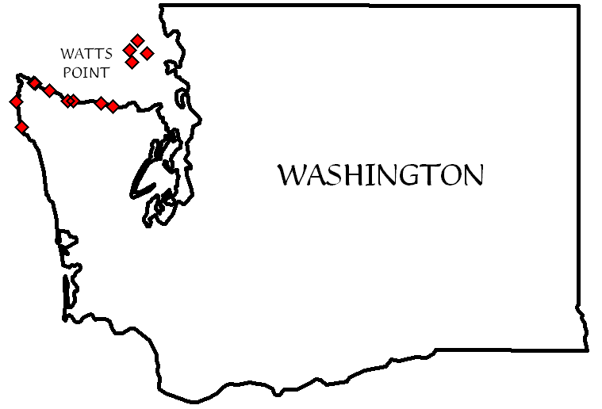 | Washington Department of Agriculture | 2007/ WAC 16-25: Disposal of dead livestock
 | Washington Department of Ecology | 2005/ On-Farm Composting of Livestock Mortality
 | Washington Department of Health | 2007/ WAC 246-203-121 Disposal of dead animals
 |  | 2005/ RCW 70.95.306: Composting of bovine and equine carcasses - Guidelines - Exemption from solid waste handling rules
West Virginia | West Virginia Department of Agriculture | 2011/ 19-0-34 Disposal of carcass of diseased animal
 |  |  | What is covered in the document
State | Department | Year/Code (with weblink) | Compost | Render | Landfill | Bury | Burn | Other
Wisconsin | Wisconsin Department of Agriculture, Trade and Consumer Protection | 2007/ Wis Stats 95.50 Disposition of Carcasses
Wyoming | Wyoming Department of Environmental Quality | 2006/ Wyoming DEQ Solid Waste Guideline #17: Guidance for Composting Animal Mortalities at Farms, Ranches and Exempt Animal Feeding Operation Facilities
 |  | 2001/ Wyoming Statute 35-10-104: Dead Animal Disposal
 |  | 2007/ Water Quality Rules and Regulations, Chapter 1, Section 14: Dead Animals and Solid Waste

